## Exercise 22.1.1: Growing Circles

## Growing Circles

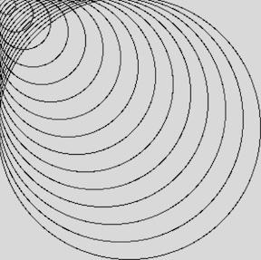

Write a program that will draw circles on the canvas until the diameter of the circle reaches the canvas height.

Circles should be placed from the upper lefthand corner and should start with a radius of 20. They should all touch the top and left side of the canvas. The radius should increase by 20 pixels with each circle. The largest circle on the canvas should span the entire height and width of the canvas.

**Hint:** The keyword break might be helpful here!